Mid lab assessment topics

Excellent, Abdullah ✅

Let’s go topic-by-topic and write proper C++ codes with full explanations so you can practice for your Mid Lab Assessment conﬁdently.

🧮Part i: Vector Operations

✅1. Finding Vector Size, Insert, Update, Delete

cpp

#include <bits/stdc++.h> using namespace std;

int main() {
vector<int> v = {10, 20, 30};

// Finding size
cout << "Size: " << v.size() << endl;

// Inserting elements v.push_back(40); // insert at end
v.insert(v.begin() + 1, 15); // insert 15 at index 1

// Updating element
v[2] = 25; // change value at index 2

// Deleting element
v.erase(v.begin() + 3); // delete element at index 3 v.pop_back(); // remove last element

// Displaying vector cout << "Final vector: ";
for (int x : v) cout << x << " "; }

🧠Explanation:

v.push_back(x) → adds element at the end

v.insert(v.begin()+i, x) → insert at index i v[i] → updates element
v.erase(v.begin()+i) → removes element at index i v.pop_back() → removes last element

✅2. 2D Vector (Insert and Display)

cpp

#include <bits/stdc++.h> using namespace std;

int main() { vector<vector<int>> v2d = {
{1, 2, 3}, {4, 5}, {6}
};

// Insert new element in 2nd row v2d[1].push_back(9);

// Insert a new row v2d.push_back({7, 8, 9});

// Display 2D vector
for (int i = 0; i < v2d.size(); i++) {
for (int j = 0; j < v2d[i].size(); j++) { cout << v2d[i][j] << " ";
}
cout << endl; }
}

🧠Explanation:

A 2D vector is a vector of vectors.

You can access elements using v2d[row][col]. Rows and columns can have diﬀerent sizes.

✅3. Sorting (Ascending & Descending)

cpp

#include <bits/stdc++.h> using namespace std;

int main() {
vector<int> v = {5, 1, 4, 2, 3};

// Ascending sort sort(v.begin(), v.end()); cout << "Ascending: ";
for (int x : v) cout << x << " "; cout << endl;

// Descending sort
sort(v.begin(), v.end(), greater<int>()); cout << "Descending: ";
for (int x : v) cout << x << " "; }

🧠Explanation:

sort(v.begin(), v.end()) → ascending

sort(v.begin(), v.end(), greater<int>()) → descending

💡Part ii: Problem Solving

✅1. Trailing Zeroes in Factorial

cpp

#include <bits/stdc++.h> using namespace std;

int main() { int n;
cout << "Enter n: "; cin >> n;

int count = 0;

for (int i = 5; n / i >= 1; i *= 5) count += n / i;

cout << "Trailing zeroes in " << n << "! = " << count; }

🧠Explanation:

Every 5 in the factorial contributes to a trailing zero (with a matching 2). We count multiples of 5, 25, 125, etc.

✅2. Count Digits in Factorial

cpp

#include <bits/stdc++.h> using namespace std;

int main() { int n;
cout << "Enter n: "; cin >> n;

if (n == 0 || n == 1) {
cout << "Digits in " << n << "! = 1"; return 0;
}

double digits = 0;
for (int i = 2; i <= n; i++) digits += log10(i);

cout << "Digits in " << n << "! = " << ﬂoor(digits) + 1; }

🧠Explanation:

Instead of calculating large factorials, we use logarithms to count the number of digits:

digits = ⌊log10(n!)⌋ + 1

✅3. Only Pluses

Problem idea:

Given an array, ﬁnd how many additions are needed to make all elements equal.

cpp

#include <bits/stdc++.h> using namespace std;

int main() {
vector<int> v = {1, 3, 5};
int mx = *max_element(v.begin(), v.end()); int moves = 0;

for (int x : v)
moves += mx - x;

cout << "Minimum + operations needed = " << moves; }

🧠Explanation:

Make all numbers equal to the maximum by adding the diﬀerence.

✅4. Make It Beautiful (Example Type)

Given an array, rearrange it so that no preﬁx sum equals the total sum.

cpp

#include <bits/stdc++.h> using namespace std;

bool makeBeautiful(vector<int> &a) { sort(a.begin(), a.end());
int total = accumulate(a.begin(), a.end(), 0); int preﬁx = 0;
for (int i = 0; i < a.size(); i++) { preﬁx += a[i];
if (preﬁx == total) return false;

}
return true; }

int main() {
vector<int> a = {3, 1, 2};
if (makeBeautiful(a)) cout << "YES"; else cout << "NO";
}

🧠Explanation:

Check if rearranging (e.g., sorting) avoids a preﬁx sum equal to total sum.

⚙Part iii: Elementary Algorithms

✅1. Linear Search

cpp

#include <bits/stdc++.h> using namespace std;

int main() {
vector<int> a = {5, 3, 8, 2}; int key = 8;
bool found = false;

for (int i = 0; i < a.size(); i++) { if (a[i] == key) {
cout << "Found at index " << i; found = true;
break; }
}
if (!found) cout << "Not found"; }

✅2. Binary Search

cpp

#include <bits/stdc++.h> using namespace std;

int main() {
vector<int> a = {2, 3, 4, 10, 40}; int key = 10;

int l = 0, r = a.size() - 1; bool found = false; while (l <= r) {
int mid = (l + r) / 2; if (a[mid] == key) {
cout << "Found at index " << mid; found = true;
break;
} else if (a[mid] < key) l = mid + 1;
else
r = mid - 1; }
if (!found) cout << "Not found"; }

✅3. Bubble Sort

cpp

#include <bits/stdc++.h> using namespace std;

int main() {
vector<int> a = {5, 1, 4, 2, 8}; int n = a.size();

for (int i = 0; i < n - 1; i++) {
for (int j = 0; j < n - i - 1; j++) { if (a[j] > a[j + 1])
swap(a[j], a[j + 1]);

} }

cout << "Sorted: ";
for (int x : a) cout << x << " "; }

✅4. Selection Sort

cpp

#include <bits/stdc++.h> using namespace std;

int main() {
vector<int> a = {29, 10, 14, 37, 13}; int n = a.size();

for (int i = 0; i < n - 1; i++) { int minIdx = i;
for (int j = i + 1; j < n; j++) if (a[j] < a[minIdx])
minIdx = j; swap(a[i], a[minIdx]);
}

cout << "Sorted: ";
for (int x : a) cout << x << " "; }

✅5. Insertion Sort

cpp

#include <bits/stdc++.h> using namespace std;

int main() {
vector<int> a = {12, 11, 13, 5, 6};

int n = a.size();

for (int i = 1; i < n; i++) { int key = a[i];
int j = i - 1;
while (j >= 0 && a[j] > key) { a[j + 1] = a[j];
j--; }
a[j + 1] = key; }

cout << "Sorted: ";
for (int x : a) cout << x << " "; }

✅6. Maximum Subarray Sum (Kadane’s Algorithm)

cpp

#include <bits/stdc++.h> using namespace std;

int main() {
vector<int> arr = {-2, 1, -3, 4, -1, 2, 1, -5, 4};

int maxSum = INT_MIN, curr = 0; for (int x : arr) {
curr = max(x, curr + x); maxSum = max(maxSum, curr);
}

cout << "Maximum Subarray Sum = " << maxSum; }

🧠Explanation:

Kadane’s algorithm keeps track of the maximum sum ending here and the global maximum.
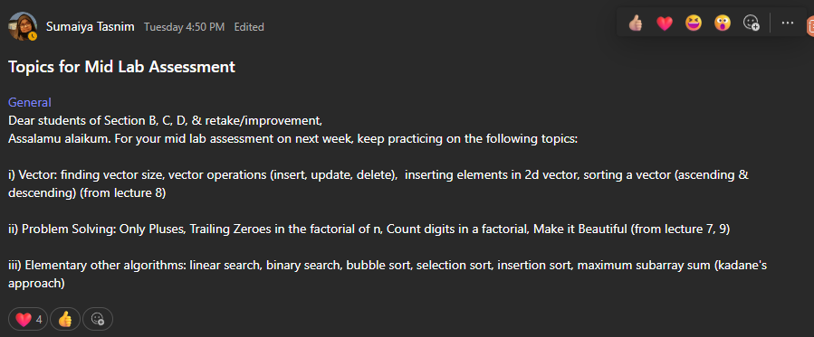
AS PER SUMAITA TASTIM MA’AM



